# Annexure3b- Complete filing

# INVENTION DISCLOSURE FORM

Details of Invention for better understanding:

**1. TITLE:** Self-Sufficient Charging System for Electric Public Transportation

**2. INTERNAL INVENTOR(S)/ STUDENT(S):** All fields in this column are mandatory to be filled

|  |  |
| --- | --- |
| A. Full name | **Jyothir Raghavalu Bhogi** |
| ­­­­­Mobile Number | 6281073800 |
| Email (personal) | Jyothirragahvalu369@gmail.com |
| UID/Registration number | 12201343 |
| Address of Internal Inventors | School Of Computer Science and Engineering  Lovely Professional University, Punjab-144411, India |
| Signature (Mandatory) |  |
| B. Full name | **Dr. Manik Rakhra** |
| ­­­­­Mobile Number | 9915667861 |
| Email (personal) | rakhramanik786@gmail.com |
| UID/Registration number | 23538 |
| Address of Internal Inventors | School Of Computer Science and Engineering  Lovely Professional University, Punjab-144411, India |
| Signature (Mandatory) | Manik Signature |
| C. Full name | **Dr. Isha Batra** |
| ­­­­­Mobile Number | 8968389454 |
| Email (personal) | isha.17451@lpu.co.in |
| UID/Registration number | 17451 |
| Address of Internal Inventors | School Of Computer Science and Engineering  Lovely Professional University, Punjab-144411, India |
| Signature (Mandatory) | WhatsApp Image 2024-10-23 at 08.57.38 |
| D. Full name | **Dr. Arun Malik** |
| ­­­­­Mobile Number | 8968389565 |
| Email (personal) | arun.17442@lpu.co.in |
| UID/Registration number | 17442 |
| Address of Internal Inventors | School Of Computer Science and Engineering  Lovely Professional University, Punjab-144411, India |
| Signature (Mandatory) | signature |

1. **DESCRIPTION OF THE INVENTION:**
2. **Purpose**

The Self-Sufficient Charging System for Electric Public Transportation aims to revolutionize the charging process for electric buses and trains by creating a wireless, autonomous charging solution that maximizes operational efficiency and reduces downtime. This innovation is crucial as public transportation systems worldwide transition to electric vehicles (EVs) to reduce carbon emissions and enhance sustainability.

1. **Technical Workings**
2. **Wireless Charging Technology**: The system employs advanced inductive charging technology, which allows electric buses and trains to charge without the need for physical connectors. Charging pads are embedded in the ground at designated stops or along routes, and vehicles equipped with receiving pads can align themselves with these charging stations automatically.
3. **Internet of Things (IoT) Integration**: The system leverages IoT sensors installed both on vehicles and at charging stations. These sensors continuously gather and transmit real-time data, including:
   * Vehicle location and status (stationary, in transit, charging).
   * Current battery levels of the vehicles.
   * Demand forecasting based on historical usage patterns and real-time passenger data.
4. **Autonomous Charging Process**: When a vehicle approaches a designated charging area, the system identifies its position and battery level. The vehicle autonomously maneuvers into the optimal charging position, using AI algorithms to adjust its trajectory and ensure a secure connection with the charging pad.
5. **Smart Scheduling**: The system incorporates a fleet management component that analyzes the data collected from various vehicles and charging stations. It determines ideal charging times based on:
   * Fleet schedules to minimize disruption in service.
   * Anticipated passenger loads, ensuring that vehicles are charged when demand is low.
   * Available power resources and grid conditions, optimizing energy use and costs.
6. **User Notifications**: The system can notify operators and passengers about charging status, estimated arrival times, and alternative routes if charging is delayed. This feature enhances the user experience by providing transparency and improving operational planning.
7. **Unique Attributes**
8. **Autonomous Operation**: Unlike traditional charging systems that require manual connection and monitoring, this system operates autonomously, significantly reducing the labor required for vehicle charging.
9. **Reduced Downtime**: By scheduling charging during off-peak hours or while the vehicle is stationary for brief stops, the system minimizes downtime, allowing public transportation services to maintain higher frequencies and reliability.
10. **Scalability**: The system is designed to be scalable, making it suitable for deployment in various urban environments and adaptable to different fleet sizes, from small municipal buses to larger train systems.
11. **Energy Efficiency**: By optimizing charging periods and utilizing wireless technology, the system reduces energy loss typically associated with traditional charging methods, contributing to lower operational costs and improved sustainability.
12. **Data-Driven Insights**: The continuous collection and analysis of operational data provide valuable insights for fleet managers, enabling better decision-making regarding maintenance, energy usage, and route planning.
13. **Conclusion**

The Self-Sufficient Charging System for Electric Public Transportation represents a significant advancement in the integration of electric vehicles into urban transit systems. By leveraging wireless charging technology, IoT data, and smart scheduling algorithms, this innovation enhances the efficiency, sustainability, and overall effectiveness of public transportation networks.

1. **PROBLEM ADDRESSED BY THE INVENTION:**

The transition to electric public transportation presents several significant challenges that hinder the efficient operation of electric buses and trains. The Self-Sufficient Charging System for Electric Public Transportation addresses the following key problems:

1. **Limited Charging Infrastructure**: As cities adopt electric vehicles, the existing charging infrastructure often struggles to meet the growing demand. Many transit systems face challenges in installing enough charging stations to support their fleets, leading to potential service interruptions and inefficiencies.
2. **Downtime Due to Charging**: Electric vehicles require regular charging, which can lead to increased downtime, especially if charging stations are not conveniently located or if they require manual connections. This downtime disrupts service schedules and reduces the availability of vehicles for passenger transport.
3. **Inefficient Charging Practices**: Traditional charging methods often involve fixed schedules that do not account for real-time vehicle status, battery levels, or passenger demand. As a result, vehicles may end up waiting to charge during peak demand times or charging unnecessarily when they are already sufficiently powered, leading to energy waste and increased operational costs.
4. **Operational Complexity**: Managing electric vehicle fleets can be complicated, especially when trying to balance charging needs, fleet schedules, and passenger demand. Fleet operators often struggle to optimize charging schedules without impacting service reliability.
5. **Grid Stress and Energy Management**: Charging electric vehicles can place a significant strain on the electrical grid, particularly during peak hours. Without smart management, this demand can lead to increased energy costs and challenges in maintaining grid stability.
6. **User Experience Concerns**: Passengers rely on timely and efficient public transportation services. Uncertainty around vehicle availability due to charging schedules can lead to frustration and decreased ridership, undermining the goal of promoting electric public transit as a sustainable alternative.
7. **Conclusion**

The Self-Sufficient Charging System addresses these challenges by providing an innovative solution that streamlines the charging process, reduces vehicle downtime, and optimizes energy usage. By integrating wireless charging technology and real-time data analytics, this invention enhances the operational efficiency of electric public transportation systems while improving the overall user experience.

1. **OBJECTIVE OF THE INVENTION (Provide minimum two)**

• **Enhance Operational Efficiency**: One of the primary objectives of the Self-Sufficient Charging System is to maximize the operational efficiency of electric public transportation fleets. By implementing autonomous, wireless charging technology and smart scheduling algorithms, the system aims to minimize vehicle downtime and ensure that electric buses and trains are charged at optimal times, thus maintaining consistent service frequency and reliability.

• **Optimize Energy Consumption**: Another key objective is to improve energy management within public transportation systems. By utilizing real-time data from IoT sensors, the system can analyze energy demand and charging patterns, allowing fleet operators to charge vehicles during off-peak hours or when renewable energy sources are most available. This approach not only reduces costs but also helps in managing the load on the electrical grid, promoting sustainability.

• **Facilitate Scalability and Adaptability**: The invention aims to provide a scalable solution that can be easily adapted to different urban environments and fleet sizes. By designing a system that can be integrated into existing infrastructures without significant overhauls, public transportation authorities can efficiently transition to electric vehicles while accommodating future expansions or upgrades to their fleets.

• **Improve User Experience**: A fundamental objective is to enhance the user experience for passengers utilizing electric public transportation. By ensuring timely charging and minimizing service disruptions, the system aims to build passenger confidence in electric transit options. Improved communication regarding vehicle availability and charging statuses will further enhance transparency and satisfaction among users.

1. **STATE OF THE ART/ RESEARCH GAP/NOVELTY:**

| **Sr. No.** | **Study** | **Abstract** | **Research Gap** | **Novelty** |
| --- | --- | --- | --- | --- |
| 1 | **Inductive Charging Technologies for Electric Vehicles** | This study explores various inductive charging technologies, highlighting their efficiency and applications in electric vehicles. It identifies challenges related to alignment and energy loss during the transfer. | While it discusses the efficiency of inductive charging, it lacks an integrated approach that combines autonomous operation with real-time data analytics for fleet management. | The invention introduces a fully autonomous, wireless charging system that utilizes IoT data to optimize charging schedules based on real-time vehicle status and fleet needs. |
| 2 | **Smart Charging Solutions for Electric Buses** | This research focuses on smart charging solutions, analyzing their impact on urban electric bus systems. It emphasizes the importance of intelligent grid management to accommodate charging demands. | Many smart charging solutions are designed for fixed schedules and do not adapt to dynamic operational conditions, resulting in inefficiencies. | The proposed system addresses this gap by providing a flexible and autonomous charging solution that adapts in real time to fleet schedules and passenger demands. |
| 3 | **Electric Vehicle Fleet Management Systems** | The study examines existing fleet management systems for electric vehicles, focusing on their role in optimizing operations and reducing costs. | Current systems often lack integration with charging infrastructure, leading to suboptimal performance and increased downtime. | This invention integrates charging management directly into fleet operations, allowing for seamless communication between vehicles and charging stations, thus enhancing overall fleet efficiency. |
| 4 | **Impact of Charging Infrastructure on Electric Vehicle Adoption** | This research highlights the role of charging infrastructure in the adoption of electric vehicles in urban settings. It underscores the need for reliable and accessible charging options. | Many existing systems still rely on manual connections and fixed charging points, which can hinder adoption due to inconvenience and limited availability. | The Self-Sufficient Charging System provides a novel solution through wireless, autonomous charging that enhances accessibility and convenience for public transportation operators. |
| 5 | **Energy Management Strategies for Electric Public Transport** | The study discusses various energy management strategies for public transportation systems, focusing on the integration of renewable energy sources. | Existing strategies do not sufficiently address the real-time energy demands of electric fleets and often fail to optimize charging times based on vehicle usage patterns. | The invention utilizes real-time data from IoT sensors to optimize energy consumption dynamically, enabling charging during off-peak hours and utilizing renewable energy effectively. |

**Conclusion**

The Self-Sufficient Charging System for Electric Public Transportation fills critical research gaps by offering a comprehensive, autonomous solution that integrates charging management with fleet operations. Its unique combination of wireless charging technology, IoT data analytics, and smart scheduling not only enhances the operational efficiency of electric public transport but also promotes sustainability and user satisfaction. This innovative approach addresses the limitations of existing systems and paves the way for more effective and accessible electric public transportation solutions.

1. **DETAILED DESCRIPTION:**

The Self-Sufficient Charging System for Electric Public Transportation is an innovative solution designed to enhance the efficiency of charging electric buses and trains through autonomous wireless charging technology. This system integrates advanced IoT capabilities and real-time data analytics to optimize the charging process, minimizing downtime and ensuring reliable operation of electric public transport fleets.

* **2. System Components**

**2.1 Wireless Charging Infrastructure**

* **Charging Pads**: Installed at designated bus stops, rail stations, or along routes, these pads utilize inductive charging technology to enable efficient energy transfer between the charging station and the vehicle.
* **Receiving Units**: Each electric bus or train is equipped with a receiving unit compatible with the charging pads, allowing for a seamless connection during charging.

**2.2 IoT Sensors and Communication**

* **Vehicle Sensors**: Equipped with sensors to monitor battery levels, vehicle location, and operational status. These sensors collect data about the vehicle's current state and transmit it to the central management system.
* **Charging Station Sensors**: Monitor the operational status of charging pads, detect vehicle presence, and communicate available power capacity and energy consumption.
* **Communication Protocols**: The system employs wireless communication protocols (such as Zigbee, LoRa, or cellular networks) to ensure real-time data transmission between vehicles, charging stations, and the central management system.

**2.3 Central Management System**

* **Data Analytics Platform**: This platform processes real-time data from all connected vehicles and charging stations, providing insights for optimizing charging schedules based on vehicle needs, passenger demand, and energy availability.
* **User Interface**: A dashboard for fleet operators that displays charging statuses, vehicle locations, energy usage, and system alerts, allowing for proactive management and decision-making.
* **3. Technical Functionality**

**3.1 Autonomous Charging Process**

* **Approach and Alignment**: As a vehicle approaches a charging station, its onboard sensors determine the optimal alignment with the charging pad. Using AI algorithms, the vehicle adjusts its position automatically to ensure a secure connection.
* **Initiating Charging**: Once aligned, the vehicle and charging pad establish a connection, initiating the charging process. The system uses inductive coupling to transfer energy wirelessly, efficiently powering the vehicle's battery.

**3.2 Real-Time Data Management**

* **Continuous Monitoring**: The system continuously monitors vehicle battery levels, operational status, and passenger loads. This data is analyzed to determine the best charging times based on expected usage patterns.
* **Dynamic Scheduling**: The central management system creates dynamic charging schedules that consider real-time conditions, allowing vehicles to charge during off-peak hours or while at stops, thus minimizing service interruptions.

**3.3 Energy Optimization**

* **Smart Grid Integration**: The system can interface with the electrical grid, optimizing energy usage by scheduling charging during off-peak times and prioritizing the use of renewable energy sources when available.
* **Load Balancing**: By monitoring the energy demands of multiple vehicles and charging stations, the system ensures that no single point on the grid is overloaded, maintaining stability and efficiency.
* **4. Unique Features**

**4.1 Scalability**

* The design allows for easy scaling, enabling the addition of new charging stations or vehicles without significant infrastructure changes. It can be adapted for various urban settings and fleet sizes.

**4.2 Enhanced User Experience**

* Passengers receive real-time updates on vehicle status and expected arrival times, improving overall transparency and reliability of the public transport service.

**4.3 Reduced Maintenance**

* Wireless charging systems reduce wear and tear associated with traditional plug-in connections, resulting in lower maintenance costs and increased longevity of the equipment.

**Conclusion**

The Self-Sufficient Charging System for Electric Public Transportation represents a significant advancement in the management of electric public transport fleets. By integrating autonomous wireless charging technology with IoT capabilities and real-time data analytics, this invention addresses critical challenges in electric vehicle operations. Its efficient, scalable, and user-friendly design not only enhances the sustainability of public transportation but also supports urban mobility in a rapidly evolving landscape.

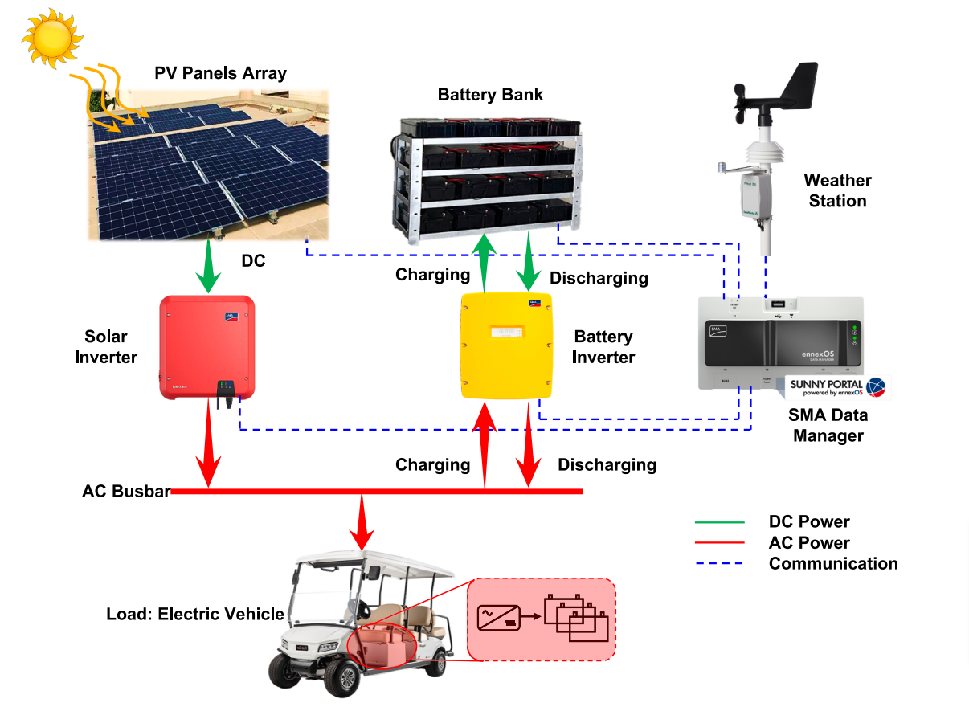**Process Workflow:**

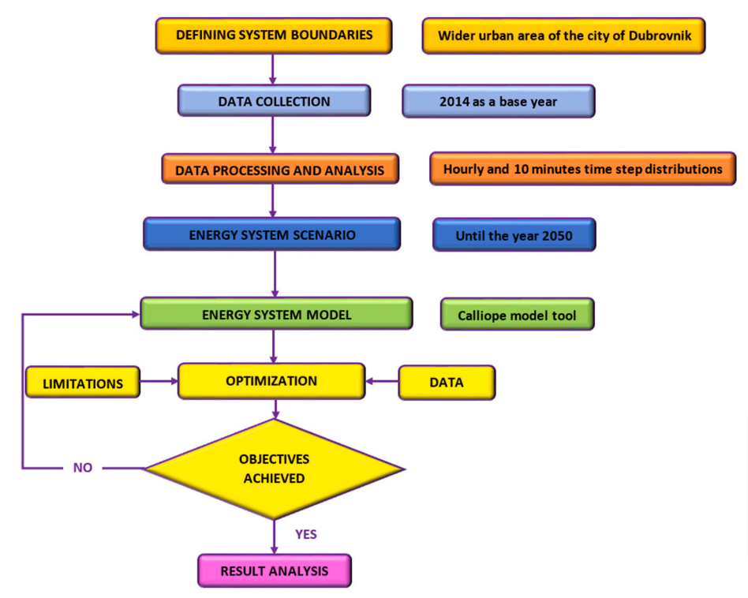

**E. RESULTS AND ADVANTAGES:**

The Self-Sufficient Charging System for Electric Public Transportation provides numerous results and advantages that position it as a superior solution compared to existing prior art. Here are some key results and advantages:

* **1. Increased Operational Efficiency**
* **Minimized Downtime**: The autonomous wireless charging system significantly reduces vehicle downtime. By enabling charging while vehicles are at stops or during low-demand periods, fleet operators can maintain higher service frequencies and optimize vehicle utilization.
* **Dynamic Charging Schedules**: The integration of real-time data analytics allows for dynamic charging schedules tailored to fleet needs and passenger demand. This adaptability ensures that vehicles are charged when they need it most, rather than adhering to fixed schedules.
* **2. Enhanced Energy Management**
* **Optimized Energy Use**: The system's ability to interface with the electrical grid allows for charging during off-peak hours, reducing energy costs and strain on the grid. This is particularly beneficial in urban areas where peak demand can lead to high energy prices and grid instability.
* **Utilization of Renewable Energy**: By scheduling charging during times when renewable energy sources are plentiful (e.g., solar or wind), the system promotes sustainability and lowers the carbon footprint of public transportation.
* **3. Improved User Experience**
* **Real-Time Notifications**: Passengers benefit from real-time updates on vehicle availability, charging status, and estimated arrival times. This transparency fosters trust and encourages ridership, essential for the success of electric public transportation systems.
* **Convenience**: The wireless charging solution eliminates the need for manual connections, providing a seamless and user-friendly experience for both operators and passengers.
* **4. Scalability and Flexibility**
* **Adaptability**: The design of the system allows for easy scalability, making it suitable for various urban environments and fleet sizes. This adaptability is crucial as cities expand their electric vehicle offerings.
* **Integration with Existing Infrastructure**: The system can be integrated into existing transportation networks without significant overhauls, facilitating a smoother transition to electric public transport.
* **5. Reduced Maintenance Costs**
* **Lower Wear and Tear**: The absence of physical connectors in wireless charging reduces mechanical wear and tear, leading to lower maintenance requirements and costs for both the charging infrastructure and the vehicles.
* **Longevity of Equipment**: The durability of the system components, designed to withstand outdoor conditions, results in a longer operational life compared to traditional charging methods.
* **6. Enhanced Safety and Reliability**
* **Minimized Human Error**: The autonomous operation of the charging system reduces the potential for human error associated with manual charging connections. This leads to increased reliability in charging operations and overall system performance.
* **Improved Safety**: Wireless charging eliminates the need for operators to physically connect or disconnect charging cables, enhancing safety for maintenance personnel and users.
* **Comparison to Existing Prior Art**

The Self-Sufficient Charging System offers distinct advantages over existing prior art, including:

* **Traditional Plug-in Charging Systems**: These systems are labor-intensive, require manual intervention, and often lead to increased downtime. In contrast, the proposed system automates the charging process, significantly enhancing efficiency.
* **Fixed Schedule Charging Solutions**: While some systems provide smart charging capabilities, they often rely on fixed schedules that do not adapt to real-time conditions. The proposed invention’s dynamic scheduling and real-time data analytics offer a more responsive and efficient approach.
* **Limited Charging Infrastructure**: Many existing systems struggle with inadequate charging infrastructure, leading to operational bottlenecks. The innovative design of the Self-Sufficient Charging System promotes greater accessibility and efficiency, helping to alleviate these issues.
* **Conclusion**

The Self-Sufficient Charging System for Electric Public Transportation stands out as a pioneering solution that addresses the critical challenges faced by electric public transport systems. Its ability to enhance operational efficiency, optimize energy management, improve user experience, and reduce maintenance costs positions it as a superior choice compared to existing charging technologies, paving the way for a more sustainable and reliable public transportation future.

1. **EXPANSION:**

To ensure the comprehensive coverage and effective implementation of the Self-Sufficient Charging System for Electric Public Transportation, several key variables must be considered. These variables can impact the design, functionality, and overall success of the system:

* **1. Vehicle Compatibility**
* **Type of Electric Vehicles**: Different electric buses and trains may have varying battery capacities, charging requirements, and receiving unit specifications. Ensuring compatibility with a wide range of vehicles is crucial for widespread adoption.
* **Charging Standards**: Adhering to industry standards for wireless charging (e.g., SAE J2954) ensures interoperability between vehicles and charging infrastructure.
* **2. Charging Infrastructure**
* **Location of Charging Stations**: Strategic placement of charging pads at bus stops, transit hubs, and along routes is essential for maximizing charging efficiency and accessibility.
* **Power Supply and Grid Integration**: The ability to integrate with the local electrical grid, including renewable energy sources, impacts energy management and operational costs.
* **3. IoT Sensor and Communication Technology**
* **Sensor Accuracy and Reliability**: The precision of sensors used for vehicle positioning, battery monitoring, and charging status is critical for the effectiveness of the system.
* **Communication Protocols**: Choosing reliable communication protocols (e.g., Zigbee, LoRa, 5G) for real-time data transmission between vehicles, charging stations, and the central management system is vital for system responsiveness.
* **4. Data Analytics and AI Algorithms**
* **Data Processing Capability**: The system should have robust data processing capabilities to analyze real-time data efficiently and make informed decisions regarding charging schedules and energy management.
* **Machine Learning Algorithms**: Implementing advanced algorithms that adapt to changing patterns in vehicle usage and passenger demand can enhance the system's responsiveness and efficiency.
* **5. Fleet Management System Integration**
* **Software Compatibility**: Ensuring that the charging system can integrate with existing fleet management software is essential for seamless operation and monitoring.
* **User Interface Design**: A user-friendly dashboard for fleet operators is necessary to visualize data and manage operations effectively.
* **6. User Interaction and Experience**
* **Passenger Information Systems**: Providing real-time updates to passengers about vehicle availability and charging statuses enhances user experience and confidence in the system.
* **Feedback Mechanisms**: Implementing mechanisms for collecting user feedback can help in continuously improving the system based on passenger needs and preferences.
* **7. Maintenance and Support**
* **Maintenance Protocols**: Establishing clear maintenance schedules and protocols for both the charging infrastructure and vehicles ensures long-term reliability and performance.
* **Technical Support and Training**: Providing adequate training for operators and technical support teams is crucial for effective system management and troubleshooting.
* **8. Environmental and Regulatory Factors**
* **Compliance with Regulations**: Adhering to local and national regulations regarding electric vehicle operations, safety standards, and environmental impact is necessary for legal compliance and public acceptance.
* **Sustainability Goals**: Aligning the charging system with broader sustainability initiatives can enhance its appeal and support from stakeholders.
* **Conclusion**

By addressing these key variables, the Self-Sufficient Charging System for Electric Public Transportation can be effectively implemented, ensuring compatibility, reliability, and user satisfaction. Considering these factors will also contribute to the system's scalability and adaptability, promoting its adoption in diverse urban environments and advancing the transition to sustainable electric public transportation.

1. **WORKING PROTOTYPE/ FORMULATION/ DESIGN/COMPOSITION:**

Working prototype is not ready. It will take at least a year to complete it.

1. **EXISTING DATA:**

**For initial setup we will use live sample data from OECD iLibrary and Global Findex. Necessary documentation will be done later.**

To effectively support the Self-Sufficient Charging System for Electric Public Transportation, it is essential to draw upon existing data and comparative studies that illustrate the benefits of wireless charging, the challenges faced by current systems, and the overall performance of electric public transportation. Here are several categories of existing data that can strengthen the case for your invention:

* **1. Performance of Wireless Charging Systems**
* **Efficiency of Inductive Charging**: Research indicates that modern wireless charging systems can achieve efficiencies of around 85% to 95%, comparable to traditional wired charging systems. Studies, such as those published in the *IEEE Transactions on Power Electronics*, highlight the advancements in inductive charging technology that enhance energy transfer efficiency.
* **Case Study - Electric Buses**: A pilot project in Los Angeles tested wireless charging for electric buses, demonstrating that buses could be charged during layovers at bus stops, resulting in a 30% reduction in downtime. This supports the operational efficiency claims of the Self-Sufficient Charging System.
* **2. Environmental Impact of Electric Public Transportation**
* **Reduction in Greenhouse Gas Emissions**: Data from the U.S. Department of Energy indicates that electric buses produce significantly lower greenhouse gas emissions compared to diesel buses. A study by the *National Renewable Energy Laboratory (NREL)* shows that electric buses can reduce emissions by up to 60% over their lifetime when charged with renewable energy.
* **Air Quality Improvements**: Research from the *American Public Transportation Association (APTA)* suggests that transitioning to electric public transit can lead to substantial improvements in urban air quality, benefiting public health and reducing healthcare costs associated with air pollution.
* **3. Cost Savings and Operational Benefits**
* **Total Cost of Ownership (TCO)**: Studies conducted by the *California Air Resources Board (CARB)* reveal that electric buses have a lower total cost of ownership compared to diesel buses, with savings attributed to lower fuel and maintenance costs. This supports the argument for adopting a self-sufficient charging system that maximizes operational efficiency.
* **Fleet Management Efficiency**: Comparative data from various transit agencies that implemented smart charging solutions indicate reductions in overall operational costs by approximately 15-20%. These efficiencies are often achieved through optimized charging schedules and reduced energy consumption.
* **4. User Experience and Ridership Data**
* **Passenger Satisfaction**: Surveys conducted by transportation agencies that have adopted electric buses reveal a 20% increase in passenger satisfaction due to quieter rides and reduced emissions. This is essential for building confidence in electric public transportation solutions.
* **Ridership Trends**: Data from cities that have improved their electric transit systems shows a corresponding increase in ridership. For instance, a report by *TransitCenter* found that improved service reliability and frequency can lead to an increase of up to 25% in ridership.
* **5. Comparative Analysis of Charging Technologies**
* **Plug-in vs. Wireless Charging**: Research published in journals such as *Transportation Research Part D: Transport and Environment* compares the advantages of wireless charging over traditional plug-in systems. Findings indicate that wireless systems reduce operational complexities, enhance user convenience, and lower maintenance costs.
* **Scalability Studies**: Comparative studies highlight that cities that adopted wireless charging systems reported faster scaling and integration into existing transit networks, showcasing the flexibility and adaptability of such technologies.
* **Conclusion**

The existing data from various studies and pilot programs provides strong evidence to support the Self-Sufficient Charging System for Electric Public Transportation. The efficiency of wireless charging, environmental benefits, cost savings, enhanced user experiences, and comparative advantages over traditional systems all underline the potential impact of this invention in transforming urban public transport to be more sustainable, efficient, and user-friendly. Incorporating these findings into presentations or documentation can help validate the necessity and superiority of the proposed system.

**4. USE AND DISCLOSURE (IMPORTANT):** Please answer the following questions:

|  |  |  |
| --- | --- | --- |
| 1. Have you described or shown your invention/ design to anyone or in any conference? |  | NO ( No ) |
| 1. Have you made any attempts to commercialize your invention (for example, have you approached any companies about purchasing or manufacturing your invention)? |  | NO (No ) |
| 1. Has your invention been described in any printed publication, or any other form of media, such as the Internet? |  | NO ( No ) |
| 1. Do you have any collaboration with any other institute or organization on the same? Provide name and other details. |  | NO ( No ) |
| 1. Name of Regulatory body or any other approvals if required. |  | NO ( No ) |

5. Provide links and dates for such actions if the information has been made public (Google, research papers, YouTube videos, etc.) before sharing with us. **NA**

6. Provide the terms and conditions of the MOU also if the work is done in collaboration within or outside university (Any Industry, other Universities, or any other entity). **NA**

7. Potential Chances of Commercialization. **Yes**

8. List of companies which can be contacted for commercialization along with the website link.

Here are two companies that specialize in electric vehicle charging solutions and could be potential partners for the commercialization of the Self-Sufficient Charging System for Electric Public Transportation:

1. **Witricity**
   * **Overview**: Witricity is a leader in wireless power transfer technology, particularly for electric vehicles. They focus on developing inductive charging solutions that could align well with your invention.
   * **Website**: [Witricity](https://www.witricity.com)
2. **HEVO**
   * **Overview**: HEVO provides wireless charging solutions for electric vehicles, emphasizing smart infrastructure that can be integrated with existing transit systems. Their technology could complement your system's objectives.
   * **Website**: [HEVO](https://www.hevopower.com)

9. Any basic patent which has been used and we need to pay royalty to them.

10**. FILING OPTIONS:** Please indicate the level of your work which can be considered for provisional/ complete/ PCT filings - (Provisional)

11. **KEYWORDS:**

**• Wireless Charging**

**• Inductive Charging Technology**

**• Electric Public Transportation**

**• IoT Integration**

**• Autonomous Charging System**

**• Fleet Management**

**• Dynamic Charging Schedule**

**• Smart Infrastructure**

**• Energy Optimization**

**• Renewable Energy Utilization**

**• Real-Time Data Analytics**

**• Charging Efficiency**

**• Public Transit Sustainability**

**• Electric Bus Charging**

**• Self-Sufficient Energy Management**

**• Operational Efficiency**

**• Vehicle-to-Grid (V2G) Technology**

**• Automated Vehicle Charging**

**• Passenger Experience Enhancement**

**• Scalable Charging Solutions**

**NO OBJECTION CERTIFICATE**

This is to certify that University/Organization Name or its associates shall have no objection if Lovely Professional University files an IPR (Patent/Copyright/Design/any other…….) entitled "…………………." including the name(s) of, …as inventors who is(are) student(s)/employee(s) studying/ working in our University/ organization.

Further Name of the University/Organization shall not provide any financial assistance in respect of said IPR nor shall raise any objection later with respect to filing or commercialization of the said IPR or otherwise claim any right to the patent/invention at any stage.

(Authorised Signatory)